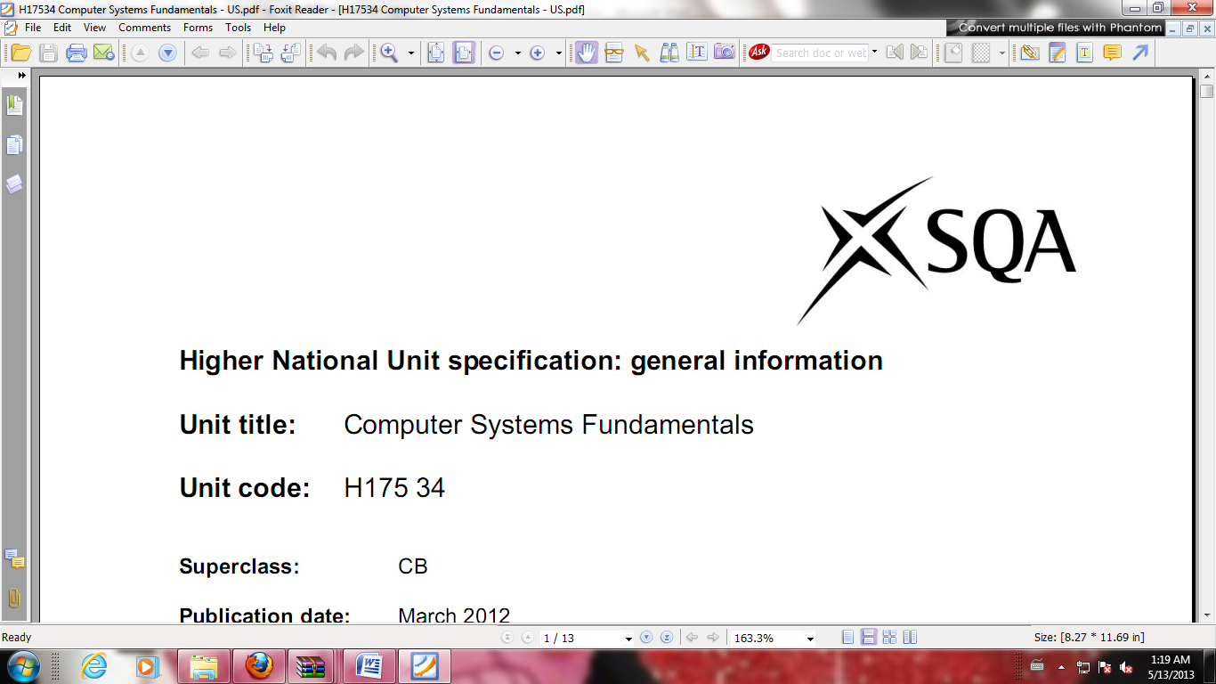

**Higher National Unit Specification: General Information**

**Statement and Confirmation of Own Work**

**Unit Title: Self Describing Data XML**

**Unit code: FM9735**

**Superclass: CB**

**Publication Date: July 2019**

**Source: Scottish Qualifications Authority**

**Version: 01**

**Student declaration**

I have read and understood SQA HND’s Policy on Academic Dishonesty and Plagiarism.

I can confirm the following details:

**Student ID/Registration number : 188706750**

**Name : Suan Thiha Nyan**

**Centre Name : KMD Computer Centre (Yangon)**

**Assessor’s Name : Ye Pyae Phyo**

**Student Signature : Suan**

**Submitted Date : July 2019**

Contents

Outcome (1) 3

Part (A) 3

Screenshot of XML Document 3

Part (B) 3

A Graphical Representation of XML Document 3

Outcome (2) 3

Screenshot of Fixed XML Document 3

Errors Correction 3

Outcome (3) 3

Screenshot of XML Source Code 3

Screenshot of XSLT Source Code 3

Result of XML combine with XSLT 3

# Outcome (1)

## Part (A)

### XML Document

## Part (B)

### A Graphical Representation of XML Document

# Outcome (2)

## Fixed XML Document

## Errors Correction

# Outcome (3)

## XML Source Code

## XSLT Source Code

## Result of XML combine with XSLT